Canadian Alliance on Race and Disability
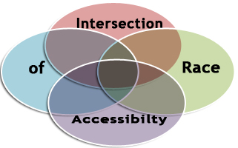

Intersection of Race and Accessibility

One Day Forum

CARD is an alliance of organizations serving the needs of diverse communities and racialized people with disabilities. Learn more about us at www.raceanddisability.ca and register now.
The purpose of this forum is to raise awareness about the barriers impacting racialized people with disabilities and to begin a conversation about an intersectionality approach to accessibility planning.
TENTATIVE PROGRAM
8:30 am | Registration/Breakfast
9:00 am | Welcome and Official Remarks | Minister MacCharles  ADM Susan Picarello*
9:30 am | Keynote and Power Exercise | Rabia Khedr*
10:45 am | Break
11:00 am | Accessibility Planning: What’s missing? | Meenu Sikand *
12:15 pm | Lunch and Poetry | Leroy Ennis*
1:15 pm | Cultural Journeys of Disability Vignettes | Moderator: David Meyers*  Mazin Aribi*  Linda Awuni  Jeyasingh David*  Selvamanikam (Bhrapa) Bhrapakaran*
2:30 pm | Break
2:45 pm | Incorporating Anti -racism into Accessibility | Moderator: Aseefa Sarang  Raihanna Hirji-Khalfan*  Ayshia Musleh  Margaret Sanderson*  Meenu Sikand*
4:00 pm | Debrief/Round Robin Exercise
4:30 pm | Closing /Official Remarks | Minister Coteau

* Confirmed

