CILT Website Refresh: Top 3 Changes

Hello everyone,

We have some good news to share with regards to the updated design of our website. The CILT team has engaged in work to update the backend mechanisms of the website to streamline with modern posting procedures and as a result, there were a few improvements made around the current design and user experience of the site.

We’ve highlighted three of these changes that may enhance your experience in navigating the site:

- New Events Calendar

When selecting the “Events” tab from the bottom of the page, you will be redirected to a calendar page with all event updates we post on the CILT website, both CILT events and community events.

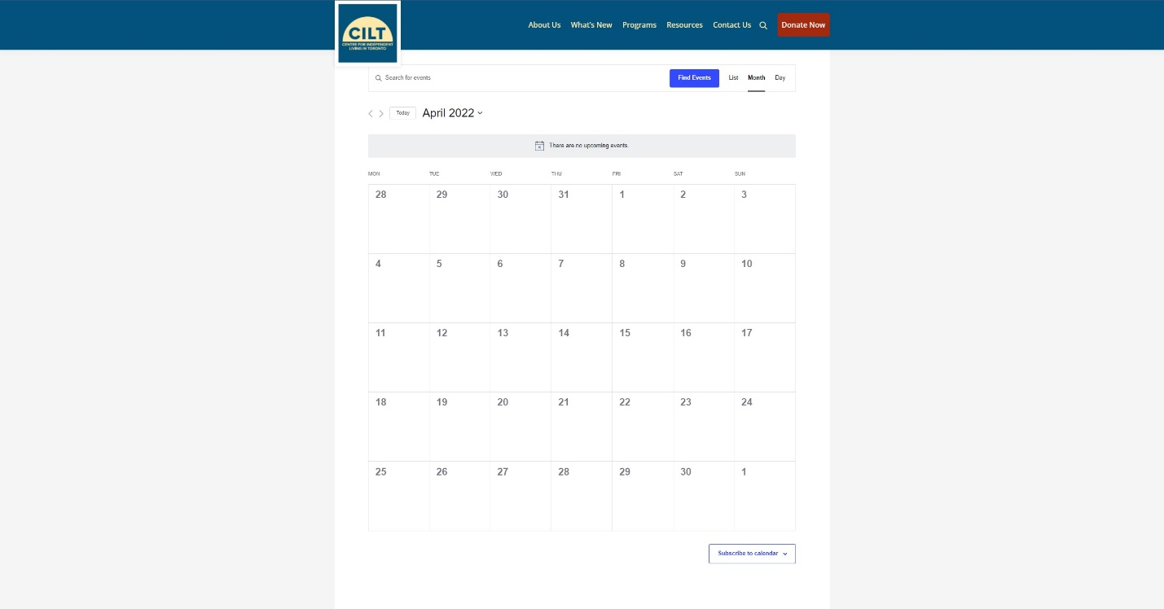

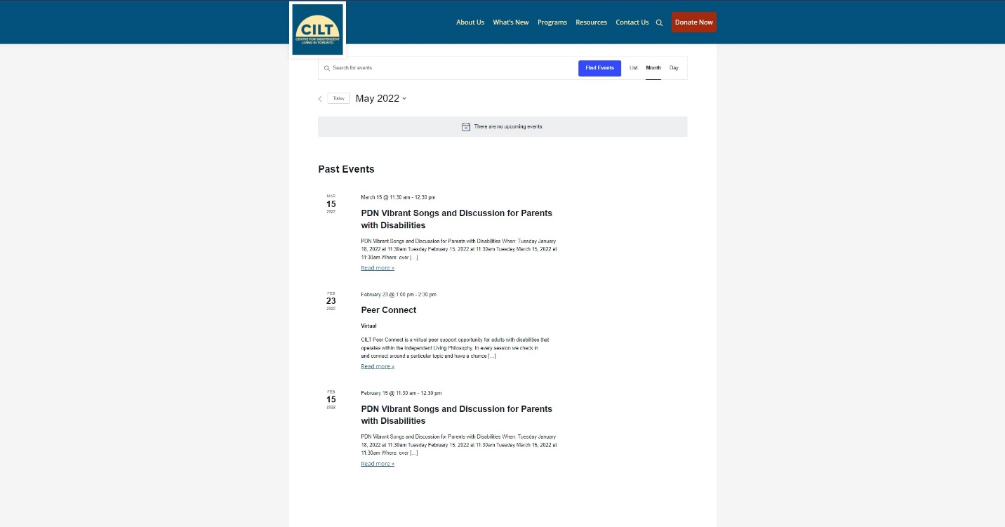

This “Events” page is now your one-stop-shop for all Event info, and rest assured, it will be updated on a continual basis. The usual “What’s New” page will be specifically reserved for announcements, information and resource sharing, etc.

- Sub-sections in Dropdown Menus

If you hover over a tab, you can now open a dropdown menu which lists all sub-pages associated with the main page of that tab.

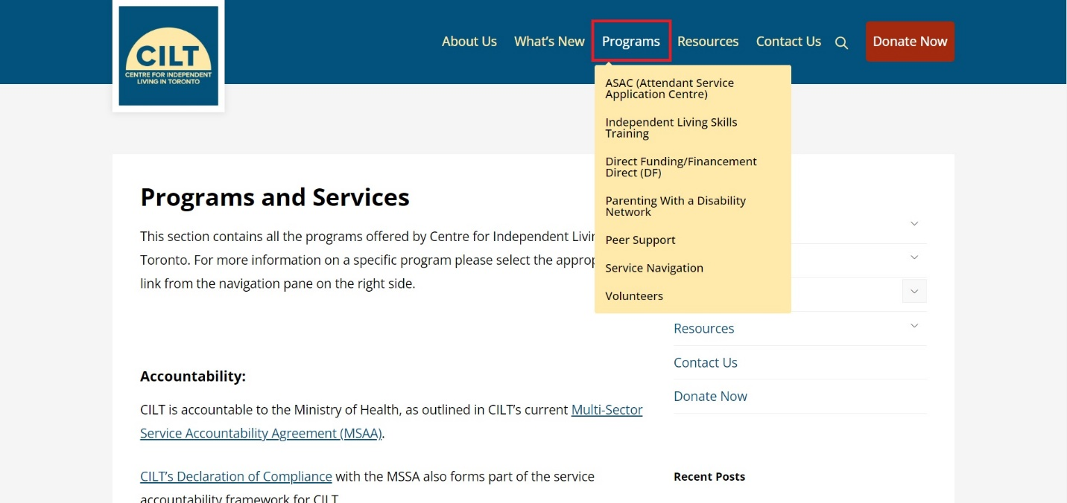

For example, if you hover over the “Programs” and services tab, a dropdown of other pages, like “ASAC, Independent Living Skills Training, Direct Funding/Financement Direct,” and so on will appear.

Another way to make these dropdown menu items appear is by de-collapsing the sections on the right-hand side of any page:

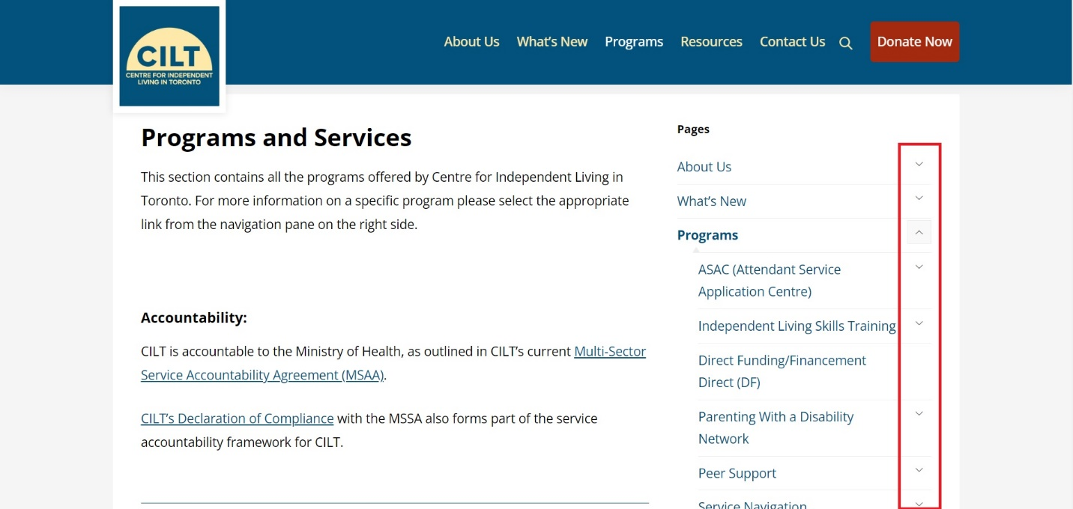
For reference, here is how the sub-page structure was layered in the previous version of the website:

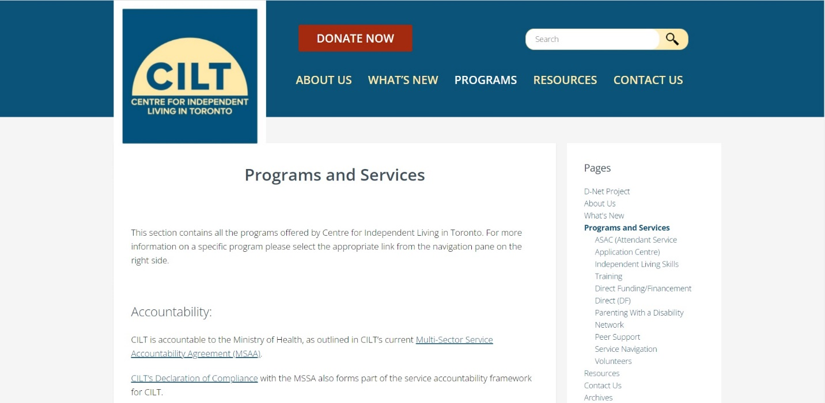
- Updated Buttons and Links

Plenty of the buttons and links have been updated with a slightly fresher and cleaner look. Hopefully it’s clearer what they are linking to and easier to navigate.

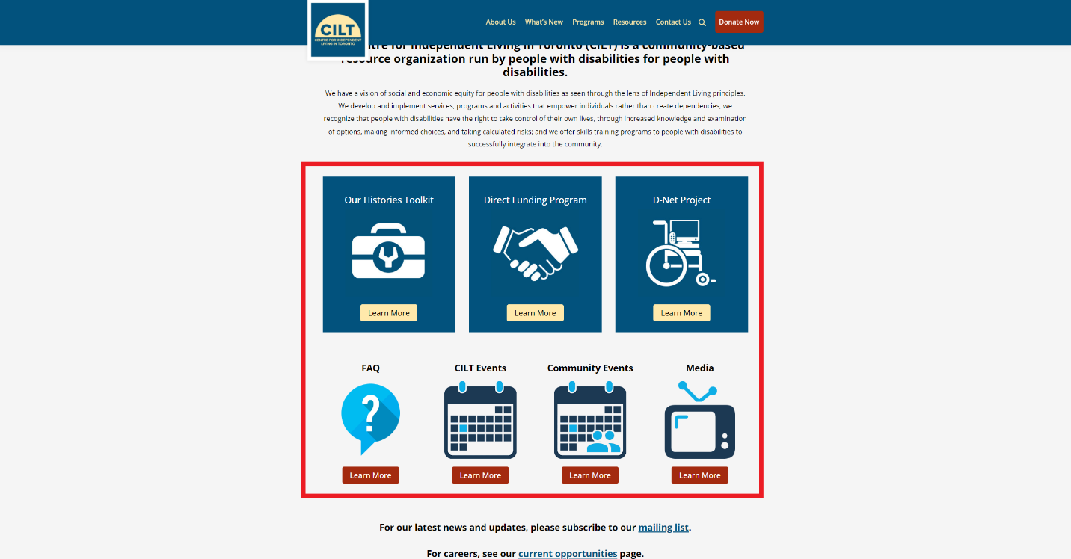

Those are the main changes to keep track of as we debut our new refreshed website. On top of other changes that will hopefully make it a smoother experience for users, you can expect the same to be applied for the mobile version of the site.

If you have any questions or concerns about the site, feel free to email cilt@cilt.ca or call 416-599-2458.

Thank you for reading!

