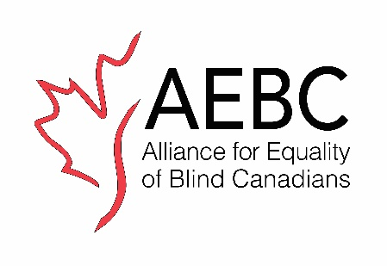
COVID-19 Focus Group - Registration Questionnaire
The Alliance for Equality of Blind Canadians, Toronto Chapter in collaboration with the Accessibility Collaborative is hosting a:

COVID-19 Focus Group Discussion

DATE: Thursday March 30, 2023 – TIME: 11:00 AM – 1:00 PM

This session aims to gather your feedback, concerns, and recommendations regarding responses to the COVID-19 pandemic with a focus on how the City of Toronto supported persons with visual impairment, Deaf and disabled people, and other marginalized communities during COVID-19

We will explore what went well, the challenges encountered along the way, where we are now, and what needs to be in place should another public health crisis occur in future, so disability communities are not left behind.

Organizations in Toronto serving persons with disabilities and marginalized communities as well as individuals with disabilities living in Toronto are welcome to join us.

Accessibility: - Communication Access Realtime Translation (CART)
- ASL-English Interpretation

To register for this focus group, please fill out the brief questionnaire below and return via email by March 24th to aebctoronto@gmail.com

Please note: this session will be recorded for internal purposes only, such as note-taking and review.

AEBC is an Accessibility Collaborative partner, a project led by the
Centre for Independent Living in Toronto. Our work is supported by the
City of Toronto’s COVID-19 Vaccine Equity Initiative.

Registration Questionnaire

We would like to know the following details to assist us with understanding representation for this focus group. All information shared will be kept strictly confidential.

Name:

Organization (if applicable):

Email:

Phone:

Preferred method of contact:

Please answer the Demographic Questions and indicate with an X before your choice.

Age:

Under 18, 18 – 29, 30-49, 50 – 64, 65 and over

Prefer not to answer.

Gender:

Male, Female, LGBTQT2S, Other

Prefer not to answer.

Occupation:

Student: high school, secondary, post-secondary, graduate level)

Prefer not to answer.

Employment:

(Occasional, part-time, full time), Self-employed, Unemployed, Retired,

Other

Prefer not to answer.

Ethnicity:

African, South Asian, East Asian, Indigenous (First Nations, Métis, Inuit), Latino, Middle

Eastern, Caucasian, Other
Prefer not to respond.

Geography:

Which neighbourhood in Toronto do you live in? For example: Parkdale, North York etc.

Prefer not to answer.

Personal Information and Access Support:

Do you identify as a person with a disability? If yes, you can specify if comfortable.

Will you require accommodations to participate in an online consultation? If yes, what accommodations will you require?

Are you representing an organization? If yes, which organization?

Please complete and send the attached pre-screen questionnaire via email to aebctoronto@gmail.com by March 24th.

Please note that there is limited space available, and you will be contacted once you have been selected for the focus group.

The answers you provide are strictly for demographic reporting, and your name will not be attached to any of our reports.

